Information Security Project Report

Submitted By:
Warisha khan (24BSSW008)
Syed Naqi Haider Jafri (24BSSW074)
Syed Muhammad Moiz Hussian (24BSSW072)
Class: SE-B
Batch: 2024th
Subject / Course: Information Security
Submitted To: Dean Dr. Zahoor Shah
Submission Date: 12-11-2026
Project: Secure Student Result Management System
Group: 11 “Secure Student Result Management System”
- INTRODUCTION AND PROJECT BACKGROUND
- Background: Academic result information is important institutional data. It may include student identities, roll numbers, subject marks, examination sessions, grades and pass/fail status. If these records are maintained only in paper ledgers or disconnected spreadsheets, institutions can face unauthorized editing, arithmetic mistakes, duplicate records, slow retrieval and limited visibility into who changed a value.
The project proposes a centralized web portal in which authenticated users work through role-specific screens. This gives each user only the functions required for their duties and provides a consistent place to store marks and result-related history.
- Project Purpose: The purpose is to demonstrate how information-security principles can be applied to a real academic workflow. The system combines authentication, authorization, input validation, secure database access and activity tracking so that marks can be managed more safely than in an uncontrolled manual process.
- Intended Users and Stakeholders
Stakeholder | Interest / Responsibility
Administrator | Controls accounts, academic structures, teacher assignments, enrollments, reports and activity logs.
Teacher | Works with assigned subjects/classes, enters marks, corrects scores when permitted and reviews their own modification history.
Student | Views their own examination results, percentages and grades; may print or save the result page.
Institution / Department | Needs reliable and accountable academic record management and controlled access to student information.

- PROBLEM STATEMENT, OBJECTIVES AND SCOPE
- Problem Statement: Traditional result-management methods may allow unauthorized access or accidental modification, depend on manual calculations, and make it difficult to trace the history of a changed mark. Students need read-only access to their own records, while teachers and administrators need controlled update rights. The project addresses these needs through a centralized role-based application with validation, calculated results and change history.
- Project Objectives:
- Develop a web-based platform for managing student academic records and examination results.
- Provide separate authenticated access for administrators, teachers and students.
- Allow authorized staff to create and manage academic records and enter marks.
- Ensure students can view their own marks without receiving mark-editing permissions.
- Validate marks against numeric and maximum-mark limits before saving.
- Calculate subject percentages, overall totals, grades and pass/fail status.
- Maintain records of mark changes and important system activities.
- Protect passwords and database operations through established application controls.
- Provide a practical result-viewing and printing experience for students.
- Project Scope:
Included in the supplied build | Not demonstrated as implemented
Login/logout and role-specific dashboards. | Two-factor authentication (TOTP).
Admin management of users, subjects, classes, examinations, teacher assignments and enrollments. | SMS and email notifications.
Teacher mark entry/update for assigned subject/class combinations. | GPA/CGPA calculation and advanced analytics.
Student result view with subject marks, percentages, letter grades and print/save-PDF option. | Native Android/iOS mobile application.
Result modification history and administrator activity log. | Cloud backup automation and full multi-department deployment.
MySQL schema, foreign keys, unique constraints and marks checks. | A standalone PDF generation service or a documented production deployment.
The application is intended to run in a web browser on a local network or hosted server. The supplied README describes an XAMPP environment and recommends configuring HTTPS, restricting database permissions and scheduled backups before production use.
- REQUIREMENTS AND USER ROLES
Functional Requirements
ID | Functional requirement
FR-01 | The system shall authenticate users with valid login credentials and support logout.
FR-02 | The system shall distinguish administrator, teacher and student roles.
FR-03 | The administrator shall create accounts and activate/deactivate users.
FR-04 | The administrator shall create and manage subjects, classes and examinations.
FR-05 | The administrator shall assign teachers to a subject and class.
FR-06 | The administrator shall enroll students in classes for an academic session.
FR-07 | Teachers shall enter or update marks only for assigned subject/class combinations.
FR-08 | The system shall reject invalid marks and values outside the permitted range.
FR-09 | The system shall calculate subject percentages, total marks, overall percentage and letter grades.
FR-10 | The system shall display the student’s own result information to an authenticated student.
FR-11 | The system shall allow an authenticated user to change their password.
FR-12 | The system shall retain a result modification history with old/new values and a reason where supplied.
FR-13 | The administrator shall view recent security and activity log entries.
FR-14 | The system shall provide result report views and browser print/save-PDF actions.
FR-15 | The system shall display an authorization error for actions outside the user’s role.
Non-Functional Requirements
Quality attribute | Requirement / interpretation
Security | Protect student records through authentication, role checks, secure password storage, prepared SQL statements and validation.
Reliability | Return consistent calculations and maintain referential integrity for academic records.
Usability | Present separate, straightforward dashboards for administrators, teachers and students.
Performance | Respond efficiently to normal login, search, mark-entry and result-view requests; formal benchmarks were not supplied.
Maintainability | Use separate PHP pages, shared include files, configuration and a relational schema.
Scalability | Use a relational schema and modular role-based pages that can be extended; high-load performance is not measured.
Compatibility | Access through a modern web browser; the README identifies Google Chrome for browser testing.
Availability / backup | Operate while the web/database services are running; scheduled backups must be configured by the operator.
Role-Based Access Control Matrix
Feature | Administrator | Teacher | Student
Dashboard | Yes | Yes | Yes
Manage user accounts | Yes | No | No
Manage subjects/classes/exams | Yes | No | No
Assign teachers / enroll students | Yes | No | No
Enter or update marks | No | Assigned class/subject only | No
View personal results | No | Relevant records through work/history | Own records only
View result modification history | All records | Own entries | No
View system audit log | Yes | No | No
Change own password | Yes | Yes | Yes
Print / save result | Result report view | No separate student grade card | Yes
This matrix summarizes the intended and coded role boundaries. The teacher mark page checks that the selected assignment belongs to the logged-in teacher; the student results page filters marks using the student profile associated with the logged-in user.
- SYSTEM ARCHITECTURE AND MODULES
- High-Level Architecture: The supplied project follows a conventional three-layer web architecture. Users access the presentation layer in a browser. Apache serves the PHP application, where authentication, role checks, form validation and result calculations run. PDO connects the PHP code to the MySQL database, which stores users and academic data.
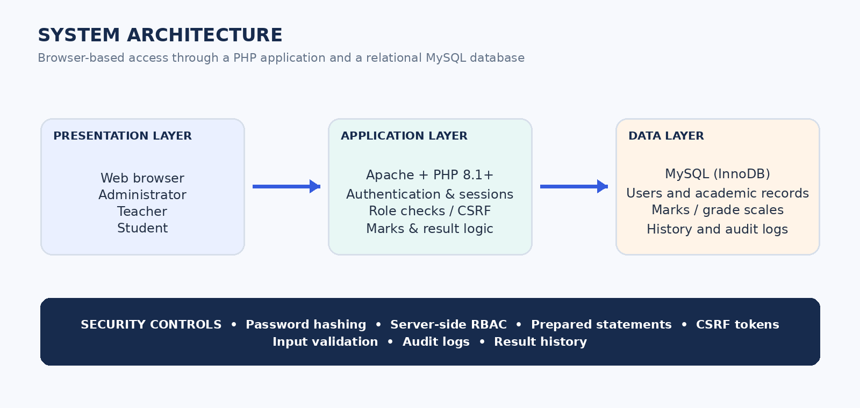
High-level system architecture. The diagram separates the browser interface, PHP application logic and MySQL storage, with security checks applied in the application layer and database constraints.
- Technology Stack
Component | Technology / purpose
Frontend | HTML5, CSS3 and JavaScript; Bootstrap 5 components and custom CSS.
Backend | PHP 8.1+ according to the README.
Database | MySQL 5.7+ or MariaDB; InnoDB storage engine and relational constraints.
Database access | PHP PDO with prepared statements and emulated prepares disabled.
Web server / local stack | Apache, with XAMPP recommended in the README.
Development tools | Visual Studio Code and phpMyAdmin; the presentation also lists Git/GitHub.
Browser testing | Google Chrome is identified in the proposal.
- Application Modules
Module | Responsibilities
Authentication and session module | Login, logout, password verification, login attempt counting, temporary account lockout, session regeneration and password change.
Administrator module | Account creation/status changes, subjects, classes, examinations, teacher assignments, student enrollments, reports and audit log review.
Teacher module | Lists assigned subject/class combinations, loads the enrolled students for an examination, accepts marks and records mark changes.
Student module | Displays the logged-in student profile and their own result rows, then provides a browser print/save-PDF action.
Marks management module | Validates numeric obtained marks and maximum marks, inserts or updates marks and stores a history row.
Result calculation module | Calculates percentages, sums marks across an exam, obtains letter grades from grade_scales and derives pass/fail status.
Audit and history module | Separates general activity events in audit_logs from mark-level revisions in result_history.
Report module | Filters administrator result reporting by examination and supports browser printing.

- DATABASE DESIGN
The SQL script created the secure_result_db database using utf8mb4 character encoding and InnoDB tables. It defines primary keys, unique values and foreign-key relationships to keep account and academic records linked consistently.
- Tables in the SQL Schema
Table | Primary key | Important attributes / relationships | Purpose
users | user_id | username, password_hash, role, name, status, failed_attempts, locked_until, last_login | Stores login identities, roles and account state.
students | student_id | user_id (FK), roll_number (unique), department, semester | Links a student profile to a login account.
teachers | teacher_id | user_id (FK), department | Links a teacher profile to a login account.
subjects | subject_id | subject_name, subject_code (unique), credit_hours | Stores the subject catalogue.
classes | class_id | class_name, department, semester | Defines class or cohort groupings.
enrollments | enrollment_id | student_id (FK), class_id (FK), academic_session | Associates students with classes and sessions.
teacher_subjects | assignment_id | teacher_id (FK), subject_id (FK), class_id (FK) | Defines the teacher’s assigned teaching scope.
exams | exam_id | exam_name, semester, academic_session, exam_type | Stores examination definitions.
marks | mark_id | student_id, subject_id, exam_id, obtained_marks, total_marks, updated_by, updated_at | Stores subject-level marks and the last updater.
results | result_id | student_id, exam_id, total_marks, maximum_marks, percentage, grade, status | Provides a schema structure for an exam-level result record.
grade_scales | grade_id | minimum_percentage, maximum_percentage, grade | Stores configurable percentage-to-letter-grade ranges.
result_history | history_id | user_id, student_id, subject_id, exam_id, old_marks, new_marks, reason, changed_at | Stores each new mark or mark revision.
audit_logs | log_id | user_id, action, old_value, new_value, target_id, ip_address, timestamp | Stores selected security and administrative activity events.
- Main Relationships and Constraints
- Each student and teacher profile is linked to a user account through a unique user_id foreign key.
- Enrollments connect students to classes for a particular academic session; the student/class/session combination is unique.
- Teacher_subjects connects a teacher to a subject and class; duplicate combinations are prevented.
- Marks reference a student, subject, examination and the user who last updated the mark. A student/subject/exam combination is unique.
- The marks table includes a check constraint requiring obtained_marks to be zero or greater, total_marks to be greater than zero, and obtained_marks not to exceed total_marks.
- Foreign-key actions include cascades for selected profile and enrollment relationships, preserving referential consistency when parent records are deleted.
- Database Implementation Note: The SQL schema defines a results table, but the PHP pages that display student results and administrator reports query marks directly and calculate the totals/percentages in the page logic. The PHP files do not insert or update rows in the results table. Therefore, this table is present in the database design but is not shown as an active persistence step in the current user-facing workflow.
- INFORMATION SECURITY DESIGN
- CIA Triad
CIA principle | Implementation in the supplied project
Confidentiality | Only authenticated users can enter the portal. Role checks separate administrator, teacher and student pages. The student results query uses the current user’s student profile so a student sees their own marks.
Integrity | Marks are checked in PHP before saving and constrained in the database. Teachers must select an assignment associated with their account. A result_history row stores old and new marks for mark revisions.
Availability | The system depends on the Apache/PHP and MySQL services. The proposal calls for backups, but the supplied code does not schedule or automate database backups; this must be configured operationally.
- Authentication and Password Protection
- Passwords are stored as hashes using PHP password_hash() and verified with password_verify(); the code does not store plain-text passwords in the users table.
- The login page tracks failed attempts for a known account. After five failed attempts, the account is locked for 15 minutes, as configured in config.php.
- On successful login, failed-attempt counters are reset and the session ID is regenerated to reduce session fixation risk.
- Session strict mode is enabled and the session uses a dedicated ResultHub session name.
- The application includes a password-change page that checks the current password and requires a new password of at least eight characters containing letters and numbers.
- Authorization and Session Controls: Shared helper functions require a logged-in session and verify that the current role is included in the allowed role list. Pages such as marks.php, users.php, audit.php and my-results.php apply these checks on the server side. The teacher marks page also verifies that the selected assignment belongs to the current teacher before loading its class roster.
- Form and Database Protection:
- POST forms use a session CSRF token generated from random bytes; the server compares the submitted token using hash_equals().
- Database queries use PDO prepared statements for variable values. PDO emulated prepares are disabled in the database connection configuration.
- HTML output is escaped through htmlspecialchars() to reduce the risk of reflected or stored HTML/script injection in displayed values.
- Marks are validated as numeric values and checked against zero and the maximum value before the transaction is committed. The SQL table also contains a CHECK constraint for these limits.
- Foreign keys and unique constraints prevent some invalid references and duplicate account/academic combinations.
- Auditability and Accountability: The system uses two related but distinct records. result_history stores mark-level changes, including the user, student, subject, exam, old mark, new mark, reason and timestamp. audit_logs stores selected application events such as successful login/logout, account changes, subject/class/exam setup, teacher assignment, enrollment and mark-saving activity. The administrator audit page displays the latest 300 events with timestamp, user, action, old/new values and IP address.
- Security Alignment Statement: The presentation describes the design as ISO 27001-aligned. The supplied materials demonstrate several information-security controls, but they do not include an independent ISO 27001 audit, certification or formal compliance assessment. The phrase should therefore be understood as a design aspiration rather than a certification claim.
- RESULT PROCESSING AND GRADING LOGIC
- Processing Flow: A user signs in, the application verifies the password and establishes a role-specific session. The teacher selects an assigned subject/class and an examination, loads the enrolled students and enters obtained and maximum marks. The server validates each value, saves the mark record and writes a result_history entry. Students then view the marks for their own student profile.
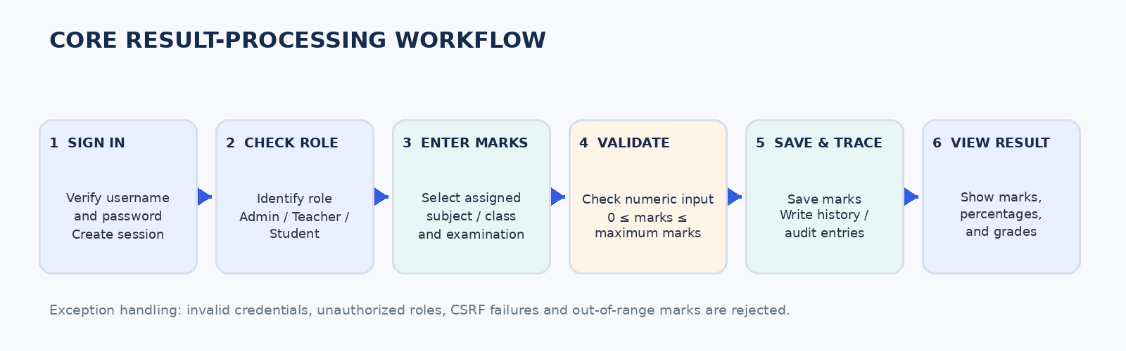Result-processing workflow. The flow summarizes the teacher-to-student result path and shows where validation and history recording occur.
- Calculation Formulas: Subject percentage is calculated using the obtained marks divided by the maximum marks, multiplied by 100:
Subject Percentage = (Obtained Marks ÷ Maximum Marks) × 100
For an examination result, the student page adds the subject marks and maximum marks for the selected exam, then calculates an overall percentage:
Overall Percentage = (Sum of Obtained Marks ÷ Sum of Maximum Marks) × 100
The code derives Pass when the overall percentage is 40 or above; otherwise it derives Fail. The letter grade for a subject and for the overall percentage is obtained from the grade_scales table.
- Grading Ranges in the SQL Seed Data:
Letter grade | Percentage range in supplied database seed
A+ | 90.00–100.00
A | 80.00–89.99
B | 70.00–79.99
C | 60.00–69.99
D | 50.00–59.99
E | 40.00–49.99
F | 0.00–39.99
- GPA / CGPA Status: No GPA/CGPA calculation routine is present in the PHP files. GPA/CGPA is therefore treated as a future enhancement, not a current implemented result.
- IMPLEMENTATION AND DEPLOYMENT GUIDE
- Important Source Files
File / group | Purpose
config/config.php | Database connection constants, session configuration and login-lockout settings.
includes/functions.php | Shared helpers for authentication checks, role checks, CSRF, escaping, audit logging and grade/status calculation.
includes/header.php / footer.php | Shared layout and role-dependent navigation.
public/login.php / logout.php | Login, logout, password verification and session handling.
public/dashboard.php | Role-specific dashboard landing page.
public/users.php | Administrator account creation and active/inactive status management.
public/subjects.php, classes.php, exams.php | Academic catalogue and examination setup.
public/assignments.php, enrollments.php | Teacher assignment and student enrollment management.
public/marks.php | Teacher mark entry/update and mark history creation.
public/my-results.php, reports.php | Student result display and administrator report display/printing.
public/history.php, audit.php | Mark revision history and administrator activity log.
public/change-password.php | Authenticated password change.
database/schema.sql / seed.php | Database tables and initial demo data.
README.md | Local setup steps, requirements and deployment cautions.
- Local Setup Requirements
- XAMPP providing Apache and MySQL
- PHP, and MySQL
- Visual Studio Code, phpMyAdmin for database administration, and a modern web browser (Chrome).
- The source folder name should remain secure-student-result-management-system unless BASE_URL in config.php is updated.
- Demonstration Accounts
Role | Demo username | Displayed account name
Administrator | admin | System Administrator
Teacher | teacher1 | Demo Teacher
Student | student1 | Demo Student
The README contains the corresponding demo passwords. They are intentionally not reproduced in this report; the accounts are for local demonstration only and must be reset before use with real student data.
- TESTING AND VALIDATION
The screenshot archive provides direct visual evidence for the invalid-credentials error and the rejection of marks above the maximum. The source code also contains the relevant role checks, prepared statements and range validation.
ID | Test | Action | Expected result | Evidence
TC-01 | Valid login | Enter active user credentials. | Role-appropriate dashboard is displayed. | Presentation: PASSED
TC-02 | Invalid credentials | Submit an incorrect username/password or inactive account. | Login is rejected with an error message. | Screenshot: invalid credentials
TC-03 | Role boundary | Open a page outside the signed-in role. | Server returns HTTP 403 or redirects to login. | Code inspection; presentation: PASSED for student edit enforcement
TC-04 | Valid mark entry | Teacher submits numeric marks within the allowed range for an assigned class. | Marks are saved and history is recorded. | Code workflow and teacher history screenshot
TC-05 | Marks above maximum | Submit obtained marks greater than total marks. | Transaction is rolled back and validation message appears. | Screenshot: marks more than max
TC-06 | Negative / invalid marks | Submit a negative or non-numeric value. | Validation rejects the input; no change is committed. | Code validation
TC-07 | SQL injection resistance | Use parameterized inputs in database queries. | User input is treated as data rather than SQL syntax. | Presentation: PASSED; PDO prepared statements in code
TC-08 | Mark revision history | Update an existing mark. | Old mark, new mark, user, time and reason are stored. | Teacher history screenshot and result_history insert
TC-09 | Student result privacy | Sign in as a student and open My Results. | Only that student’s marks are queried and displayed. | Code inspection; student screenshots
TC-10 | Activity logging | Perform supported administrative or mark actions. | A corresponding audit_logs row is displayed to admin. | Administrator audit screenshot and audit() helper
TC-11 | Print / save result | Use Print / Save PDF from My Results. | Browser print interface opens; user can choose PDF output. | Student print-preview screenshot
- Security Improvement Priorities
- Revalidate each student_id submitted to marks.php against the selected class enrollment and academic session on the server. The current POST handler checks the teacher assignment but does not repeat the roster-membership check for every submitted student ID.
- Add audit records for denied page access, failed authorization checks and suspicious request patterns, without storing passwords or sensitive payload contents.
- Confirm and centralize the official grading policy. Use the same grade thresholds and pass mark in the interface, database and course documentation.
- Use a dedicated least-privilege MySQL account, set a strong database password, enforce HTTPS for hosted deployments and restrict access to seed/setup scripts.
- Configure and test regular backups and a restore procedure. Store backups separately from the live database.
- Add automated unit, integration and security tests, plus a repeatable test report that supports any coverage percentage claim.
- Consider persisting a finalized exam result record in the results table if the institution requires a locked/published result snapshot.
- Future Enhancements
Enhancement | Potential value
Two-factor authentication | Add a TOTP authenticator step to increase protection after password login.
Email and SMS notifications | Notify students when results are published or updated.
GPA / CGPA and analytics | Implement institution-approved credit-hour formulas and student performance dashboards.
Result rechecking requests | Allow students to submit formal review requests and track their status.
Mobile application | Provide a supported Android/iOS client or responsive mobile-first experience.
Cloud backups | Store encrypted backup copies in a separately controlled cloud location.
Multi-department expansion | Extend setup and reporting for multiple departments, academic programs and campuses.
- CONCLUSION
The Secure Student Result Management System demonstrates a practical application of information-security principles to academic result management. The submitted PHP/MySQL build provides role-specific access for administrators, teachers and students; supports subject, class, exam and user setup; validates marks; calculates percentages and letter grades; records mark revisions; and presents student results through a browser interface.
The strongest implemented controls visible in the source include password hashing, login lockout, session regeneration, server-side role checks, CSRF tokens, prepared database statements, output escaping, range checks, foreign keys and activity/history records. The screenshots illustrate the main role workflows and key validation responses.
Before use with real academic data, the project should address the improvement points documented in this report. In particular, student roster membership should be checked again on mark-submission requests, denied authorization attempts should be logged, the grading matrix should be standardized, and production configuration should include HTTPS, least-privilege database access and tested backups. These refinements will strengthen the system’s confidentiality, integrity, availability and accountability.
- APPLICATION SCREENSHOTS AND EXPLANATIONS
Screenshot Details
Screenshot group | Figures | Coverage
Administrator | 1–13 | Login, dashboard, account setup, academic setup, assignments, enrollments, reporting and audit log.
Teacher | 14–17 | Teacher login, marks selection and result modification history.
Student | 18–22 | Student dashboards, empty/populated result views and print preview.
Validation / errors | 23–24 | Invalid login credentials and marks-above-maximum rejection.
- ADMINISTRATOR SCREENSHOTS: The administrator screenshots document the setup and oversight functions: login, dashboard, account and academic catalogue management, class/exam setup, teacher assignments, student enrollment, reports and activity monitoring.
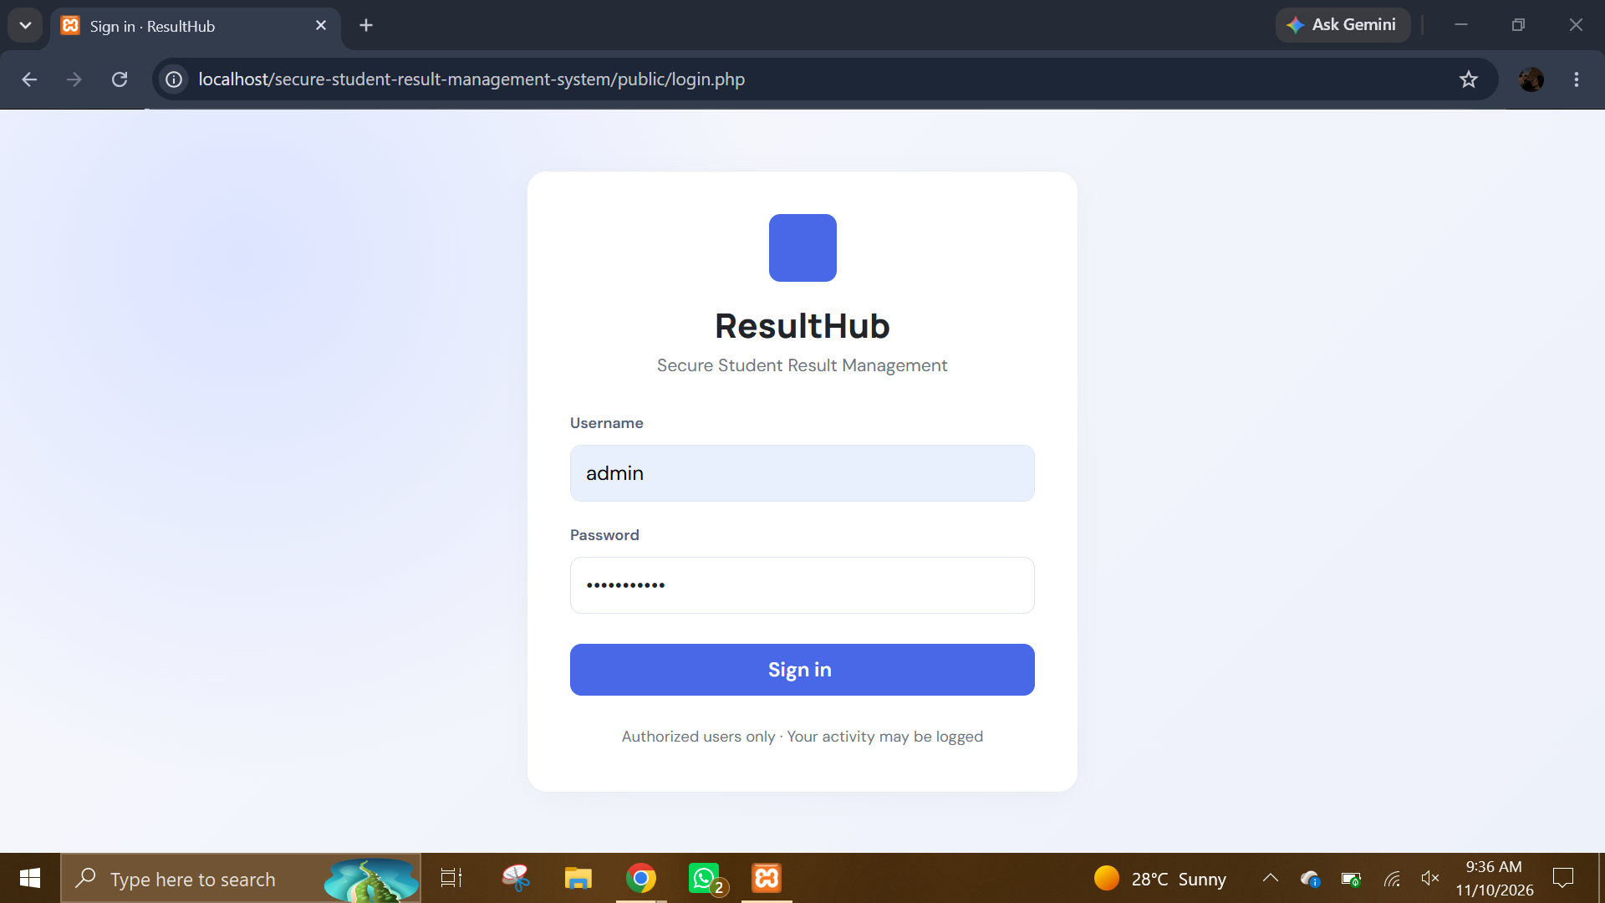
Administrator sign-in page. Shows the ResultHub login form with username and password fields. It is the entry point through which an administrator supplies credentials before receiving an authenticated session.
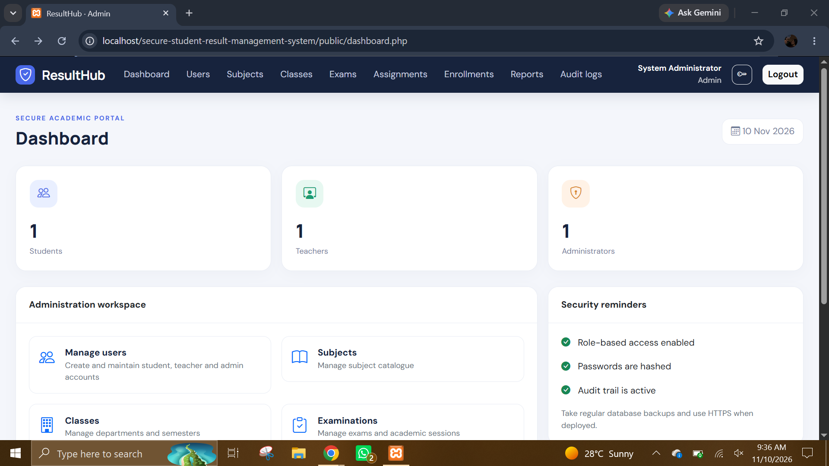
Administrator dashboard overview. Shows the administrator landing page and summary counts for students, teachers and administrators, together with security reminders. It provides a quick status view after successful login.
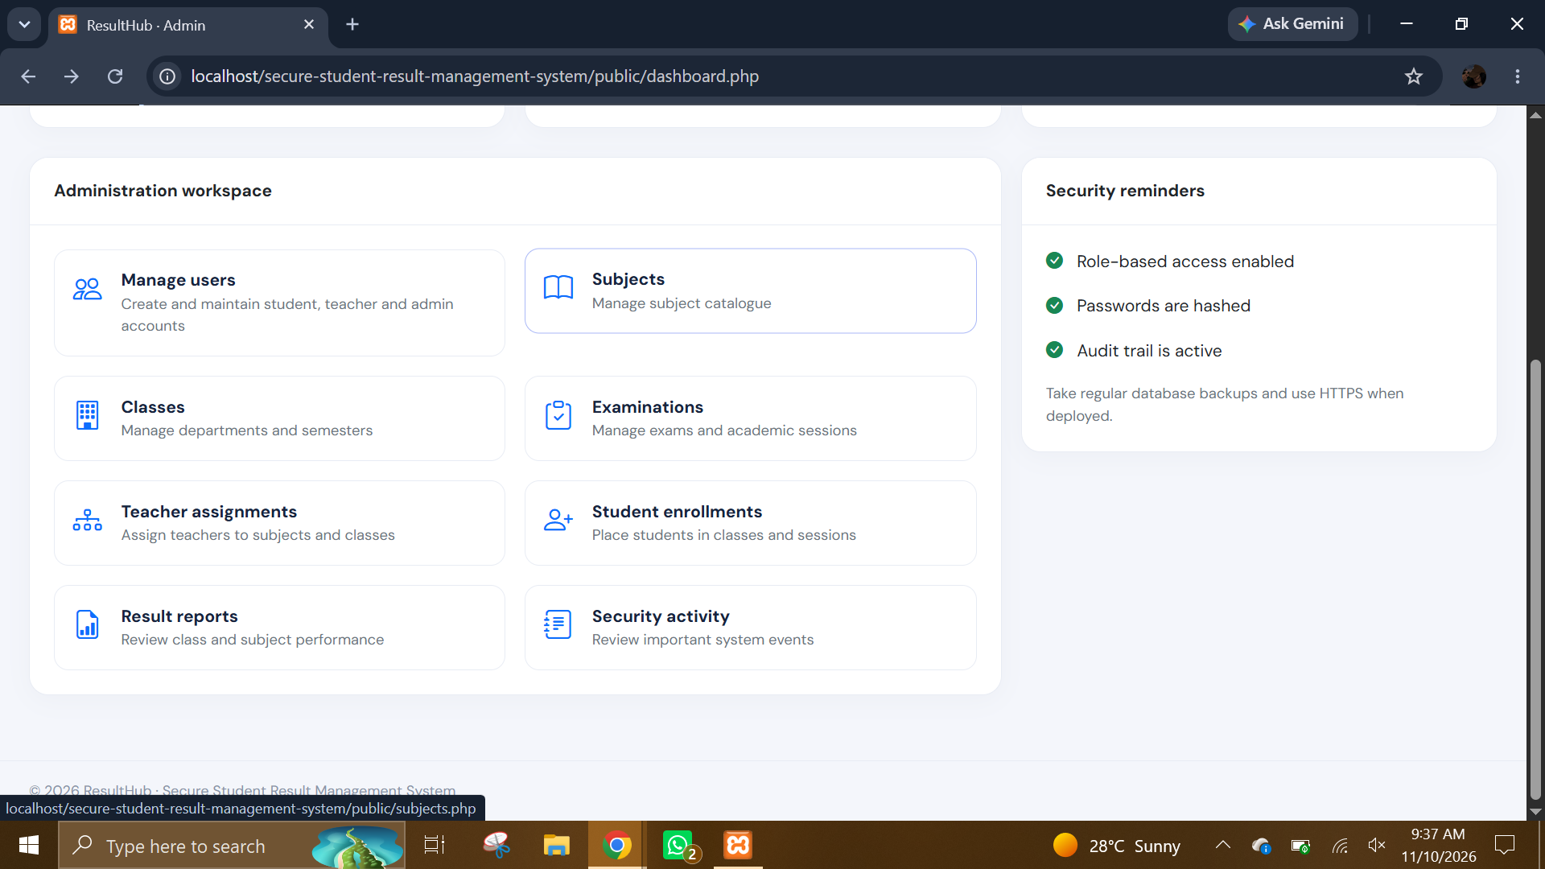
Administrator workspace shortcuts. Shows navigation cards for user management, subjects, classes, examinations, teacher assignments, student enrollments, reports and security activity. It demonstrates how administrative tasks are grouped in one workspace.
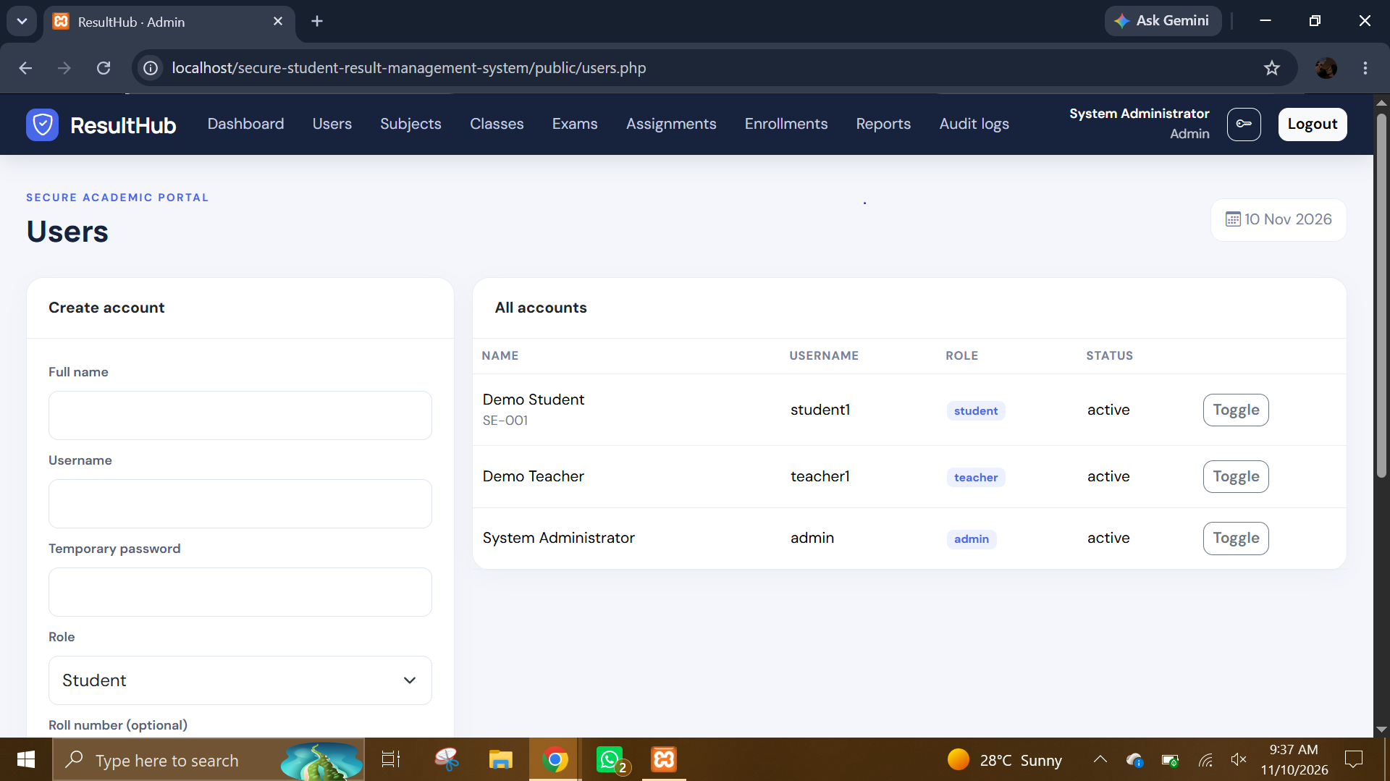
User account management. Shows the account-creation form alongside the account list with names, usernames, roles and account status. It demonstrates that administrators can create user records and review existing accounts.
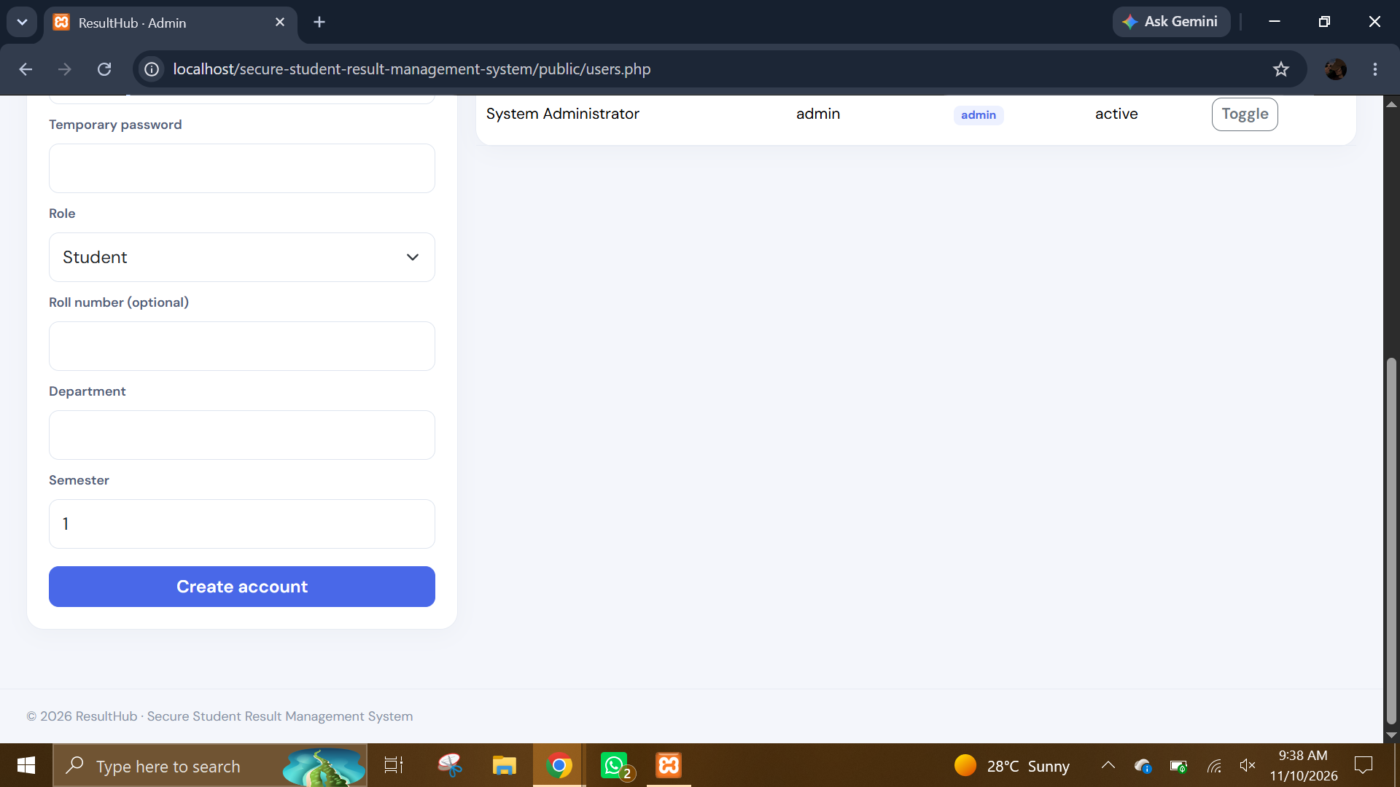
Student account profile fields. Shows the lower part of the account form, including the student role, optional roll number, department and semester fields. These fields connect the login account with an academic student profile.
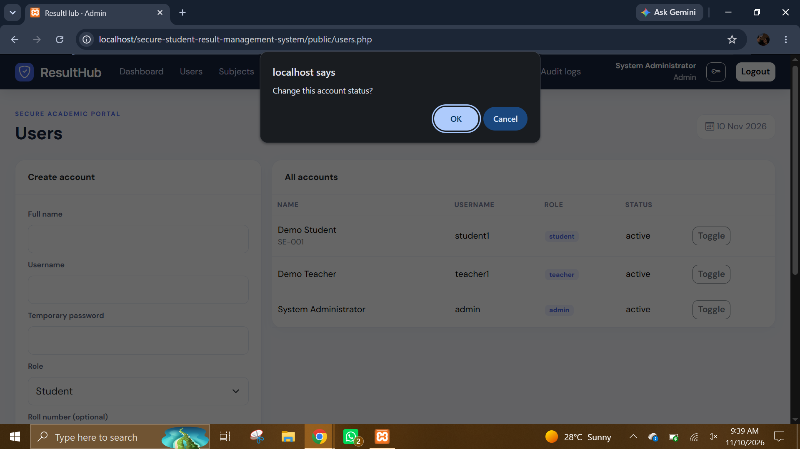
Account status confirmation. Shows the browser confirmation prompt associated with the account Toggle action. It helps prevent an administrator from changing a user’s active/inactive state accidentally.
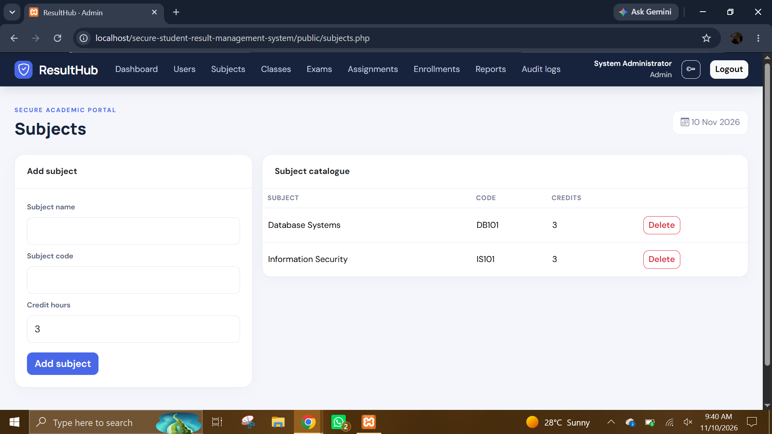
Subject catalogue management. Shows the form for adding a subject and a catalogue of existing subjects with subject codes and credit hours. Subject records are later used when creating teacher assignments and recording marks.
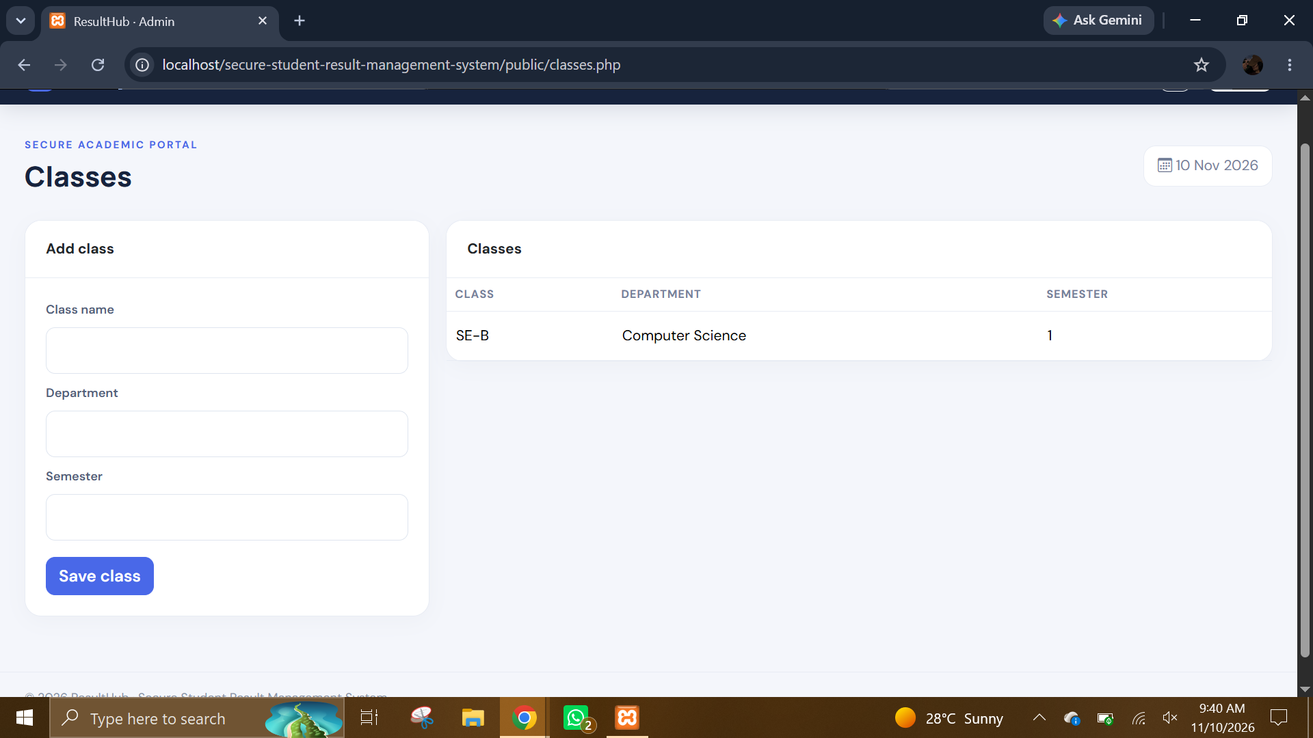
Class management. Shows the class creation form and the list of configured classes with department and semester information. Classes provide the grouping used for student enrollment and teacher assignment.
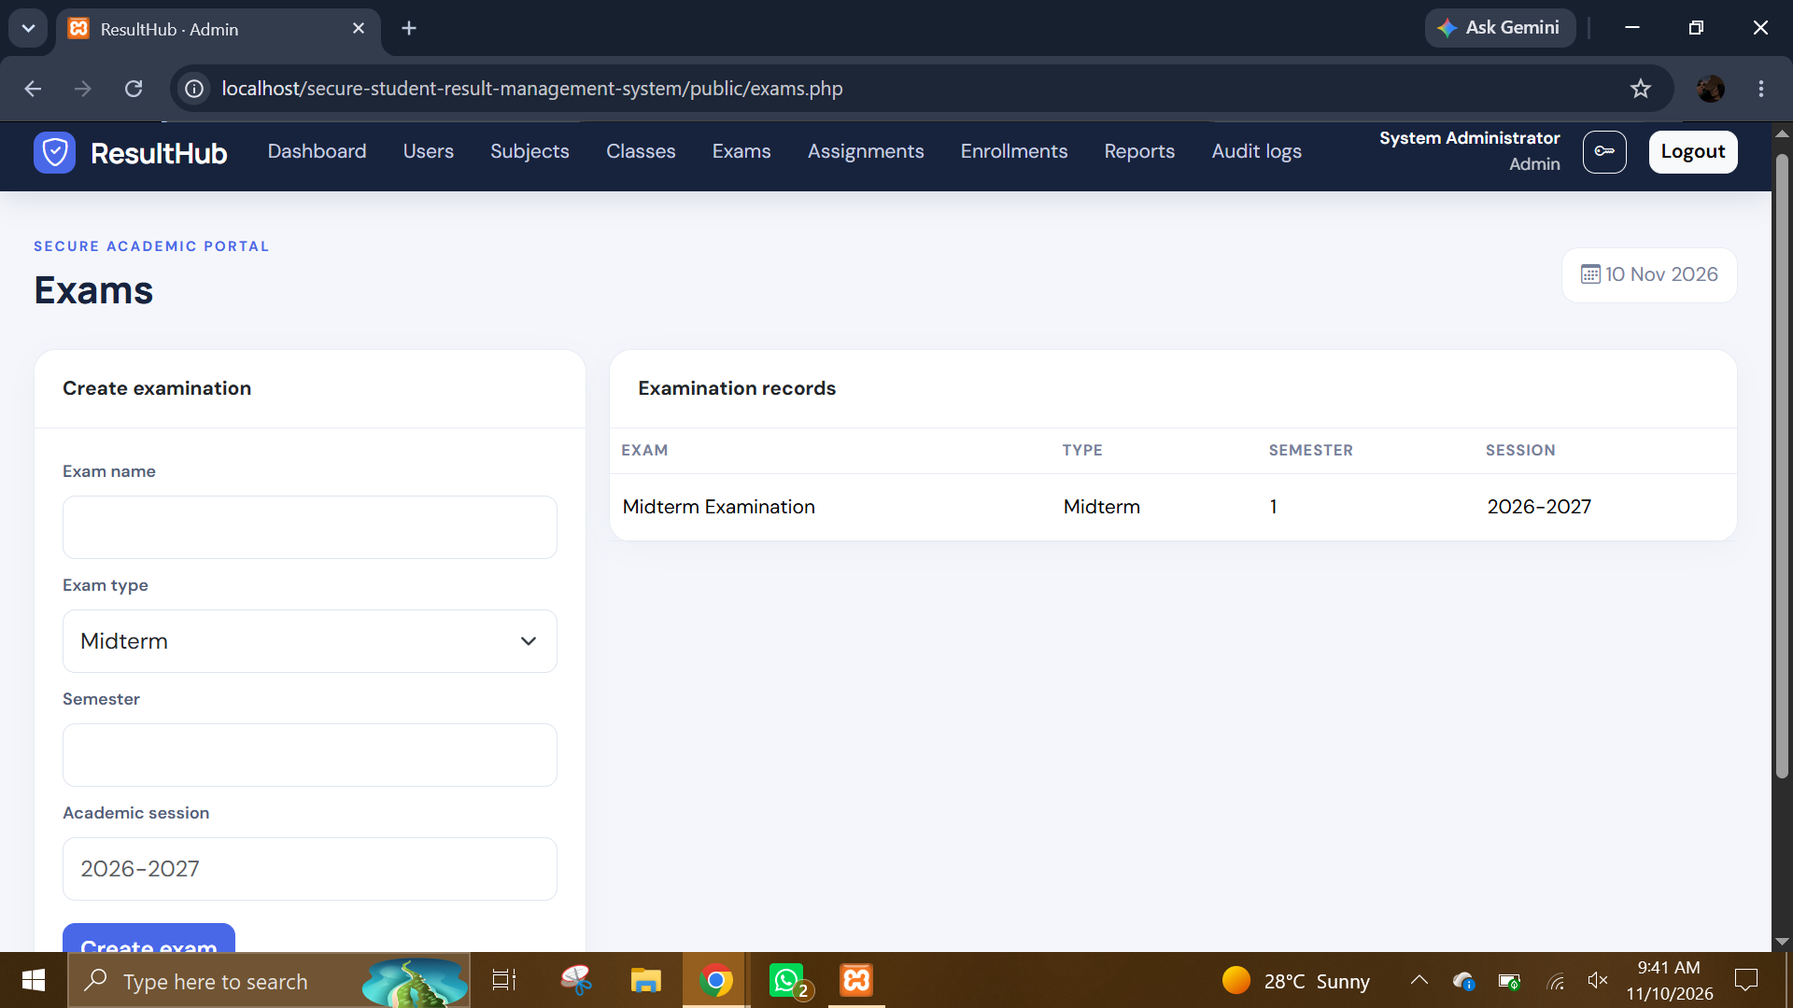
Examination setup. Shows the form for creating an examination, including its name, type, semester and academic session, together with existing examination records.
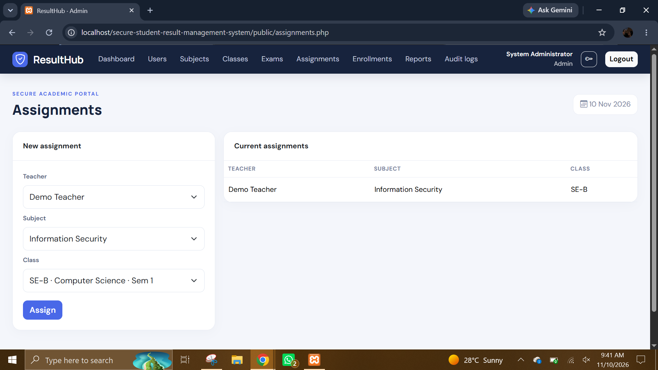
Teacher-to-subject assignment. Shows the administrator selecting a teacher, subject and class to create a teaching assignment. The assignment defines which subject/class combination a teacher can use on the marks page.
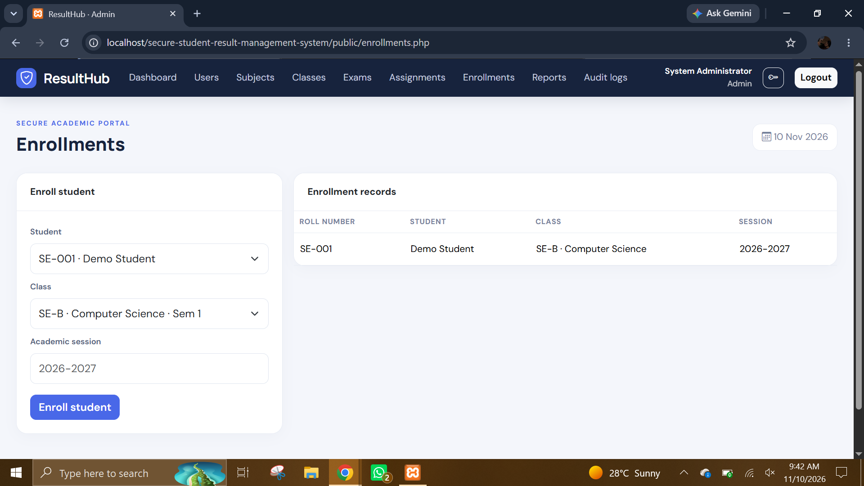
Student class enrollment. Shows the administrator selecting a student and class and specifying the academic session. The resulting enrollment links the student to the class roster used by teacher mark entry.
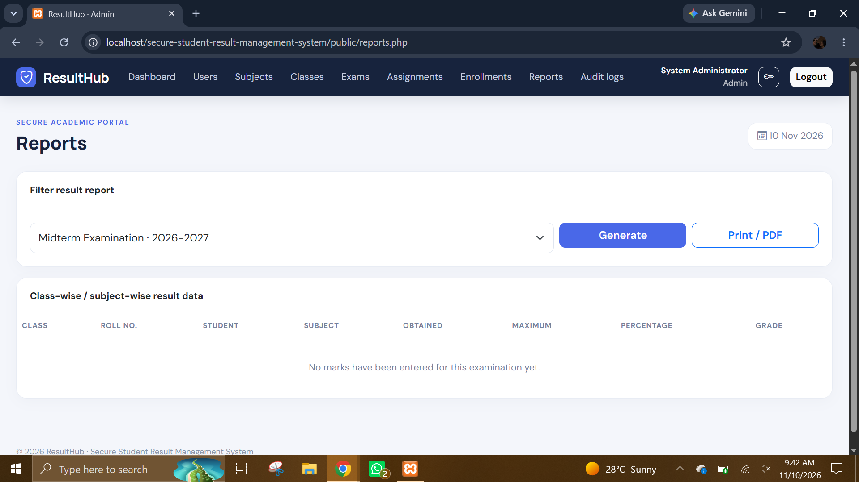
Administrator result report. Shows the examination filter and the class-wise/subject-wise report area with Generate and Print/PDF actions. The table is empty in this capture, meaning no mark rows were available for the selected exam at capture time.
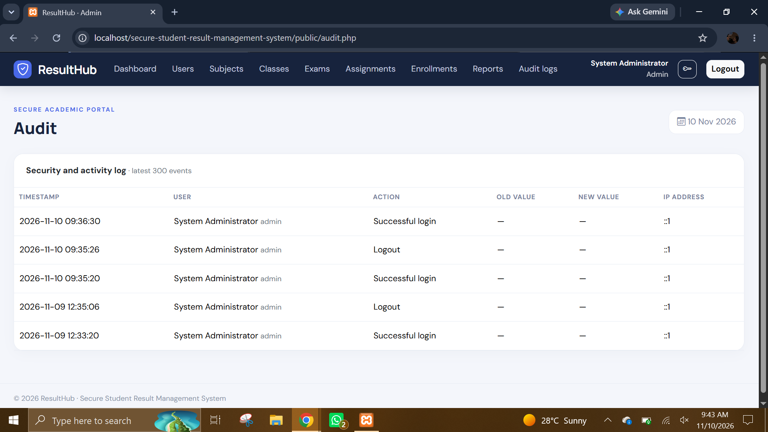
Administrator security and activity log. Shows recent activity records with timestamp, user, action, old/new values and IP address columns. It demonstrates the administrator’s view of recorded application events.
- TEACHER SCREENSHOTS: The teacher screenshots document the teacher login, selection of an assigned class/subject and examination, and the mark revision history available to the teacher.
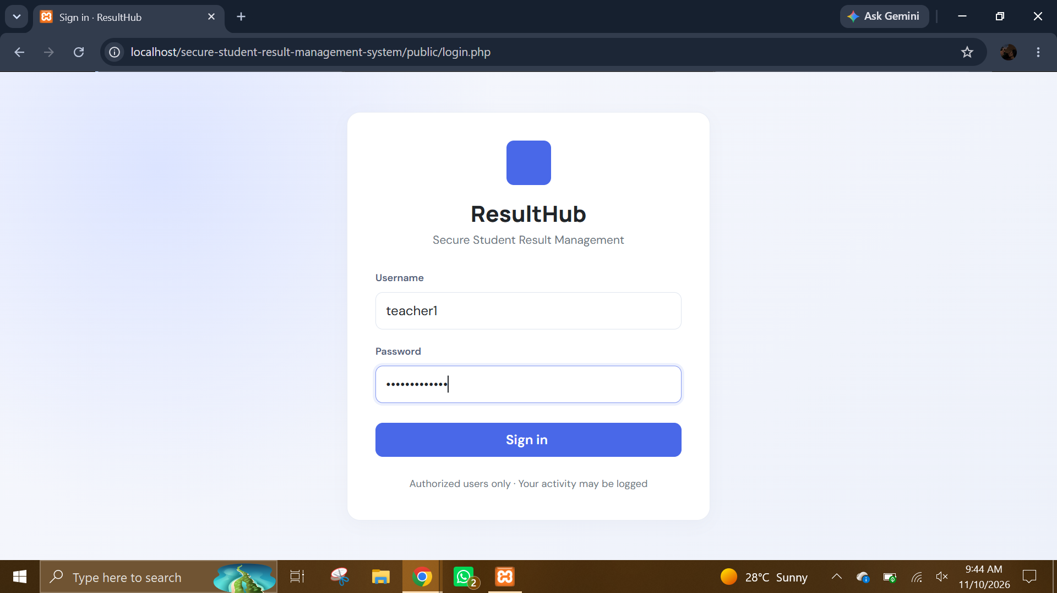
Teacher sign-in page. Shows the ResultHub login form with the teacher demo username entered and the password masked. It demonstrates that teachers use the same authentication entry point and are routed according to their role.
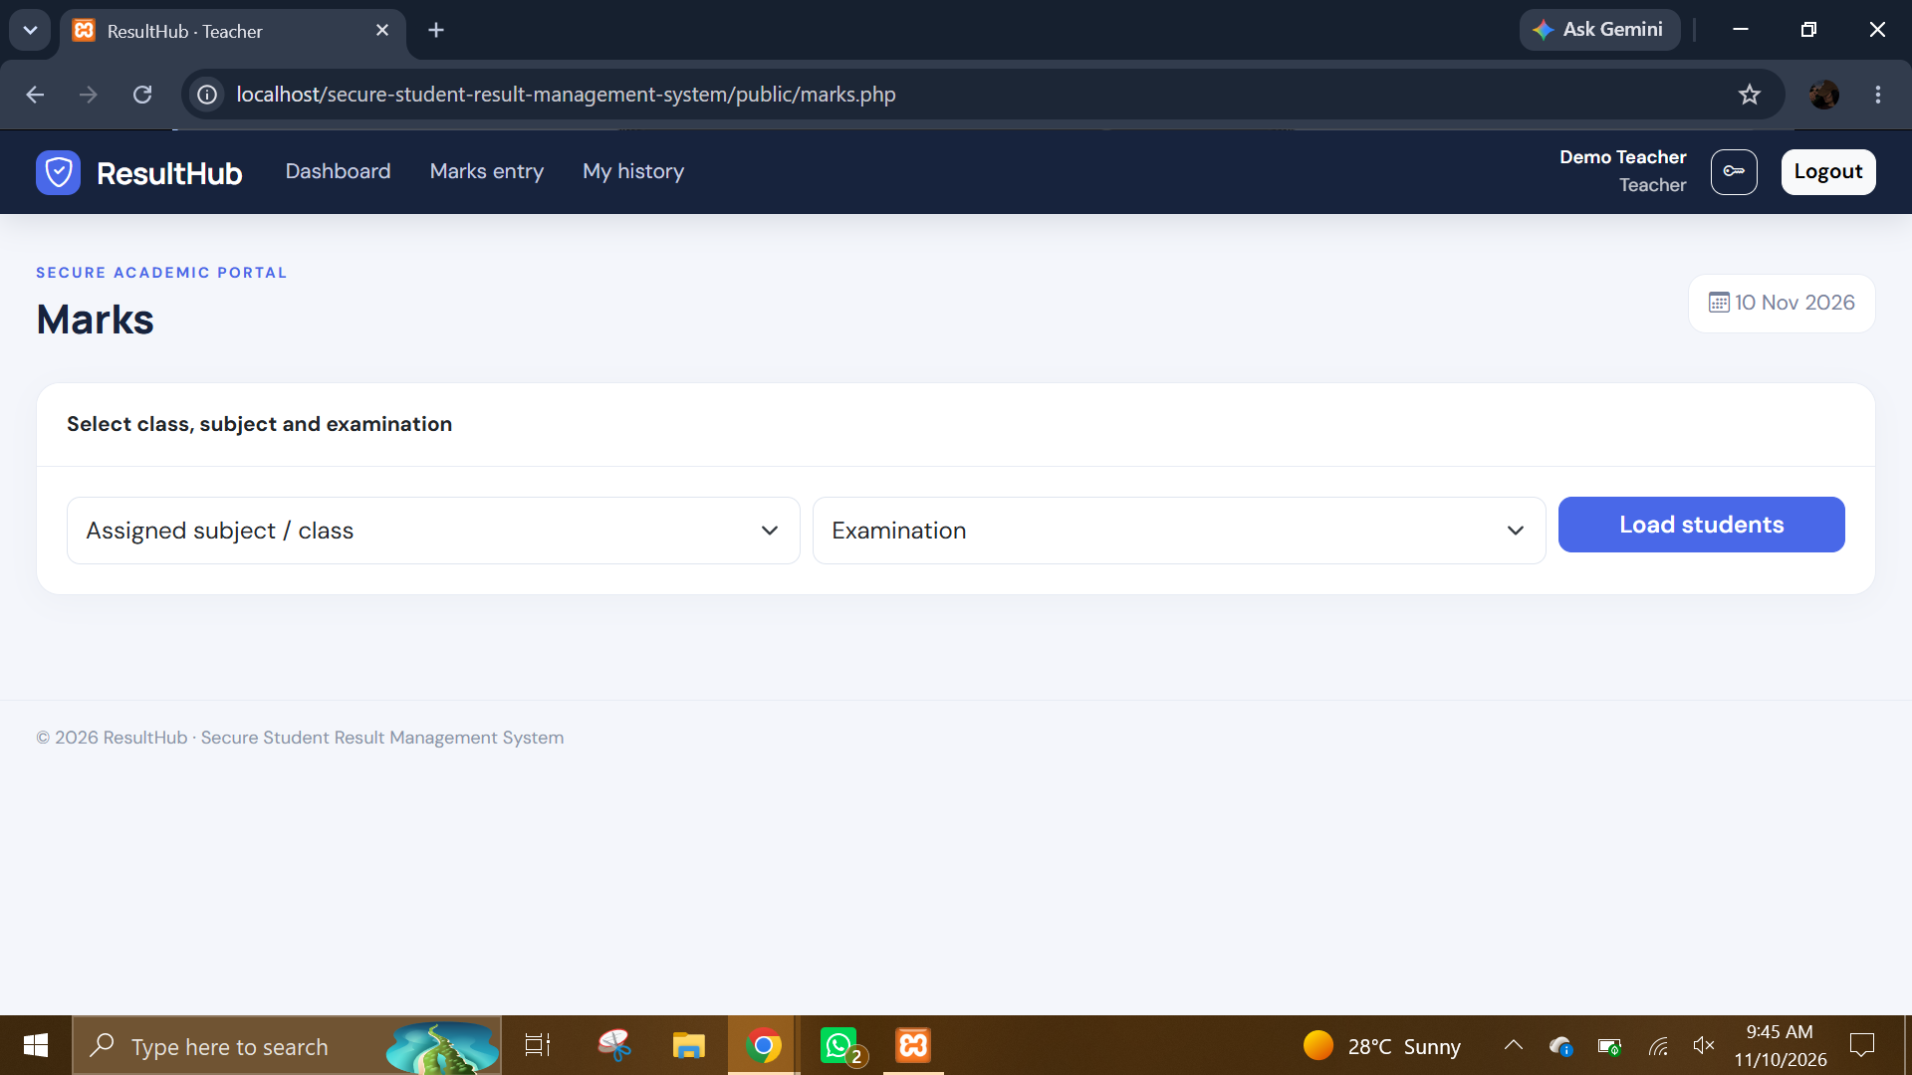
Teacher marks page - assignment and exam selection. Shows the marks page with selectors for an assigned subject/class and an examination. The teacher must select the relevant assignment and exam before loading the student roster for mark entry.
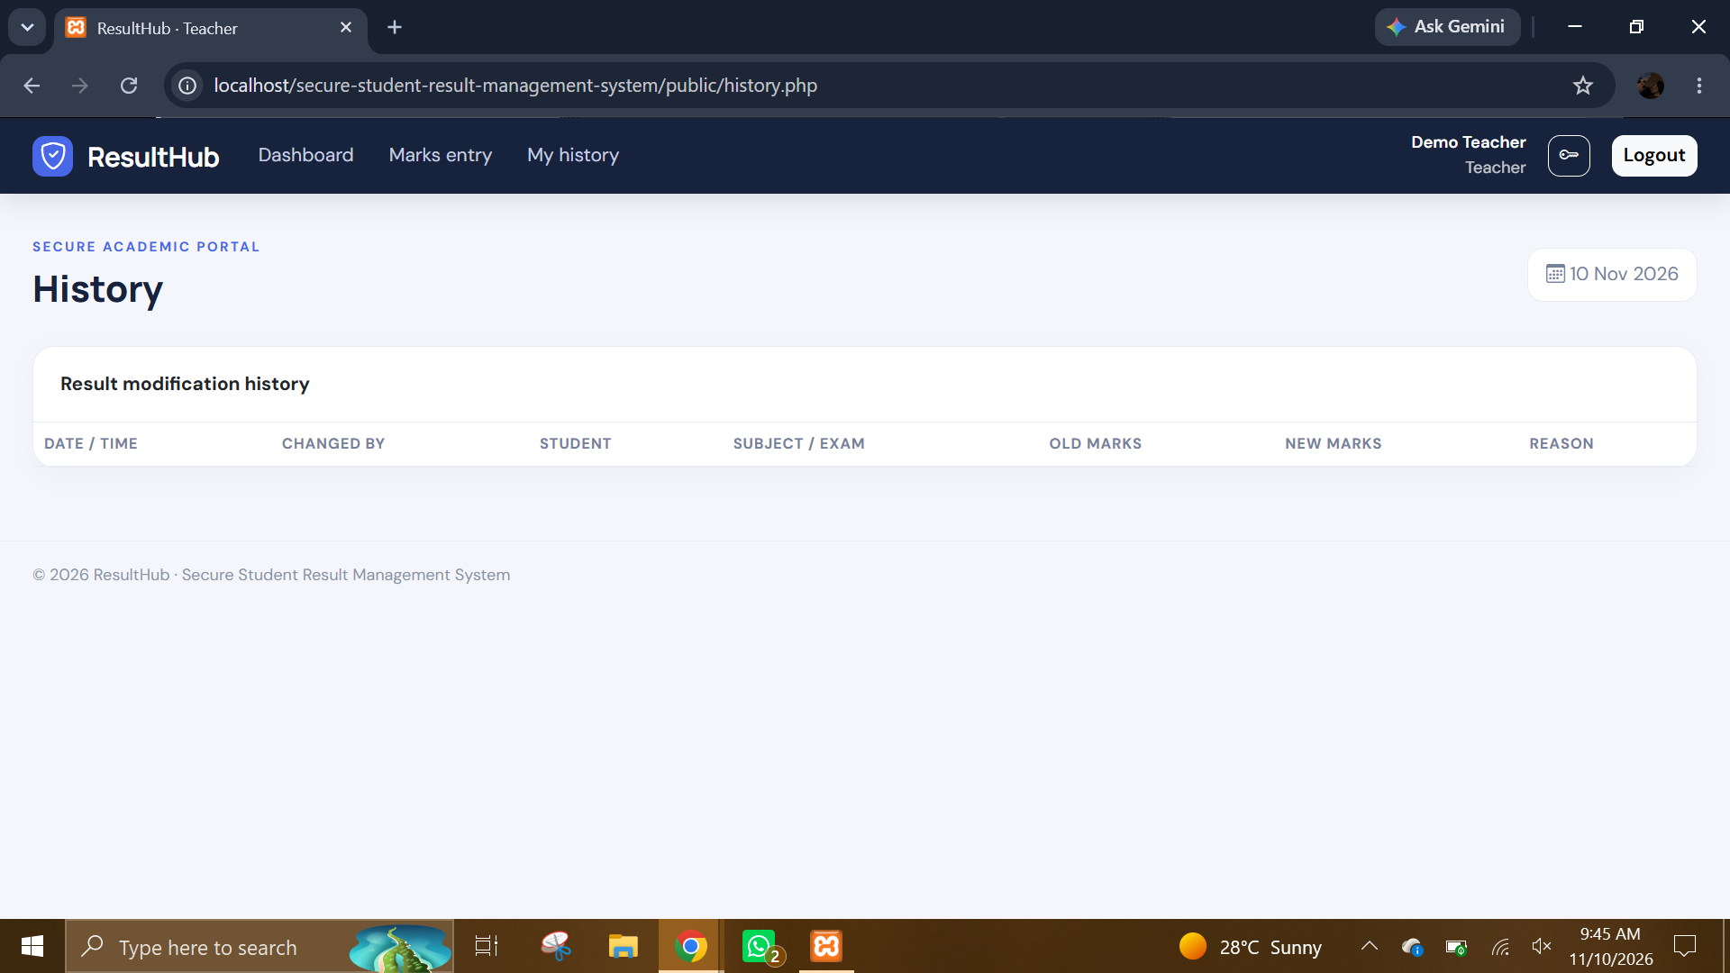
Teacher result history - empty state. Shows the result modification history table with no rows. This is an empty-state capture indicating that no history entries were available for the signed-in teacher at that moment.
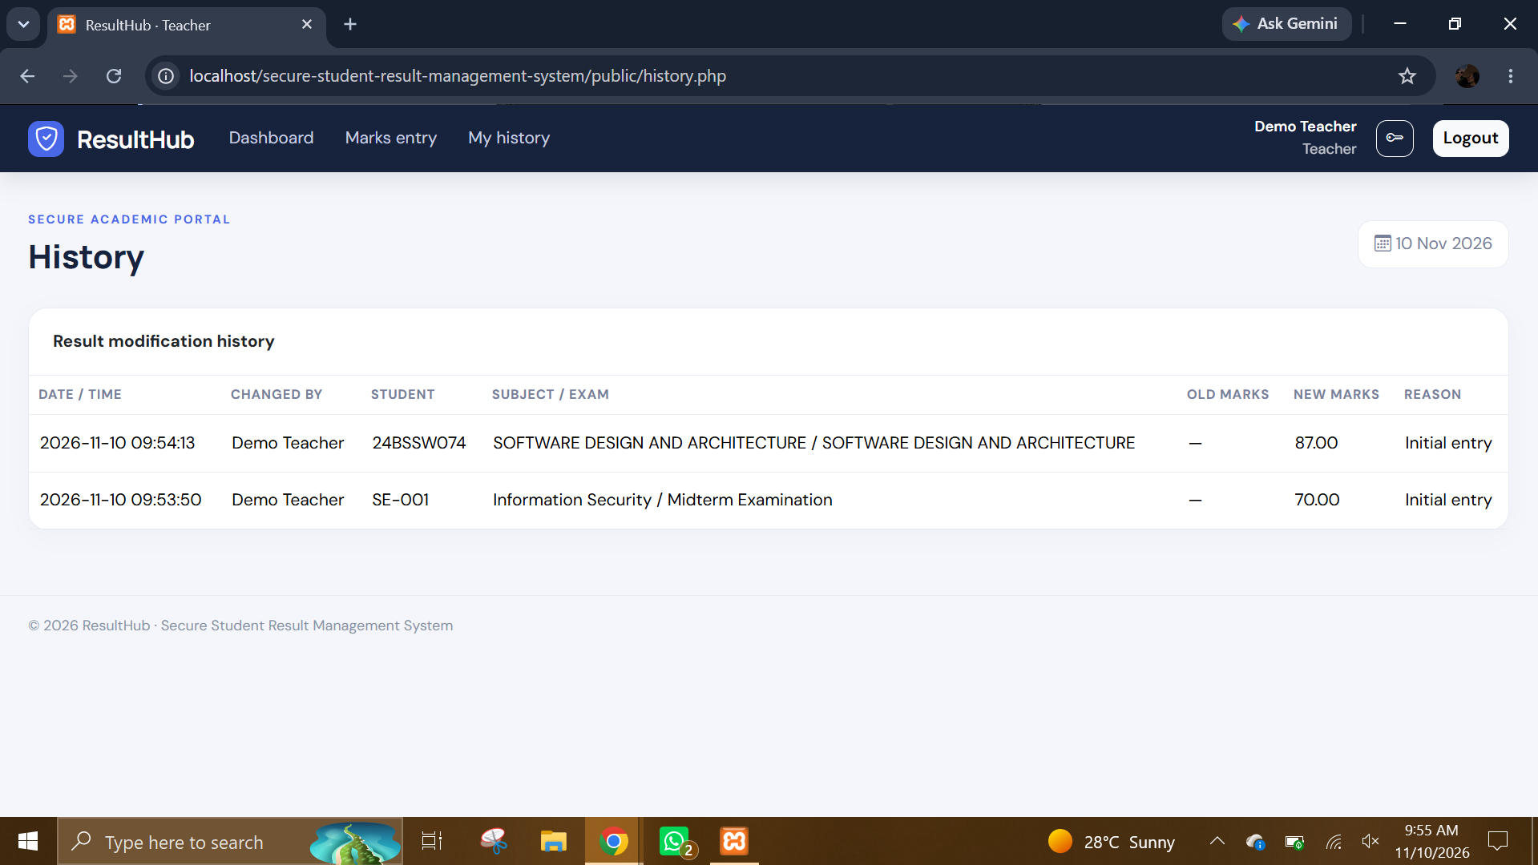
Teacher result history - populated. Shows result revision records with date/time, teacher, student, subject/exam, old marks, new marks and reason. It demonstrates traceability of initial entries or later changes to student marks.
- STUDENT SCREENSHOTS: The student screenshots document the student dashboard, empty and populated result states, and the browser print flow. Student pages are designed for viewing personal academic results rather than editing marks.
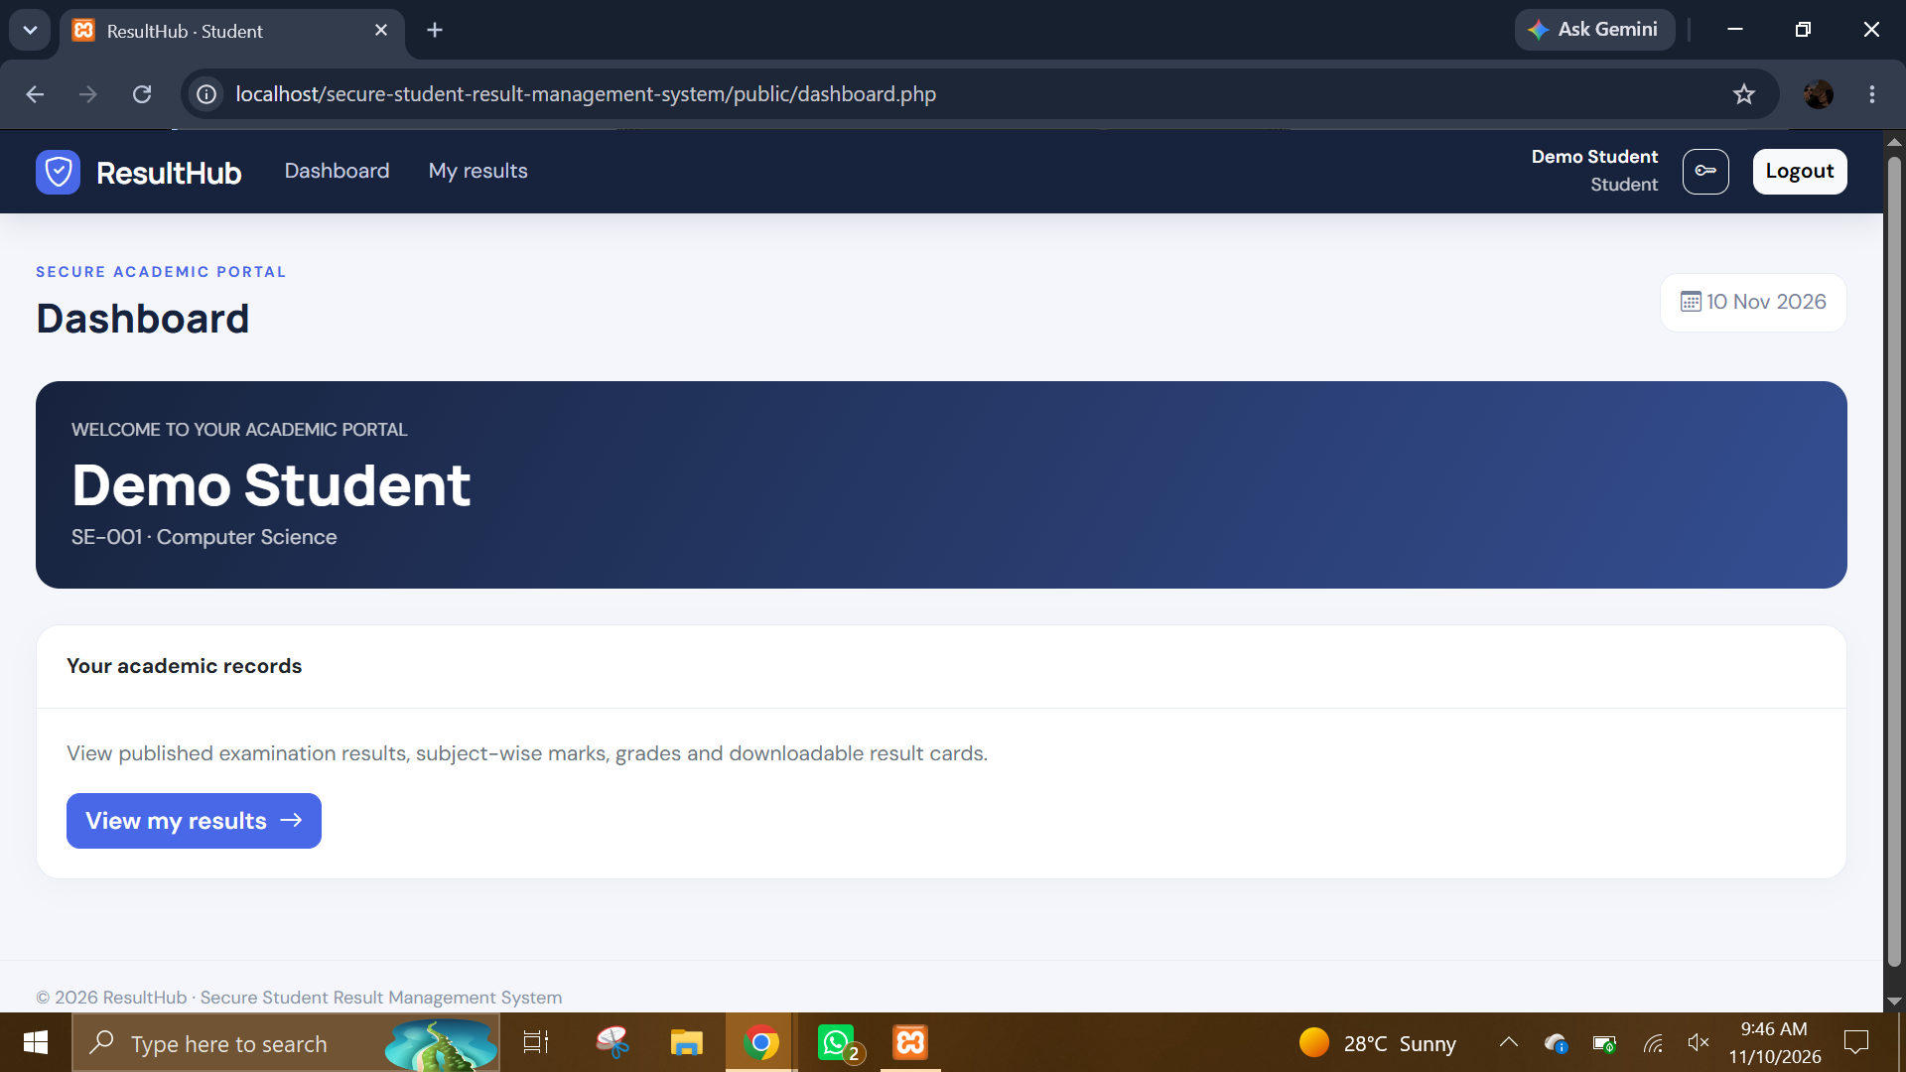
Student dashboard - demo profile. Shows the student landing page for the demo account, with the student welcome banner and a View my results link. It demonstrates that students are presented with a limited academic portal rather than administrative controls.
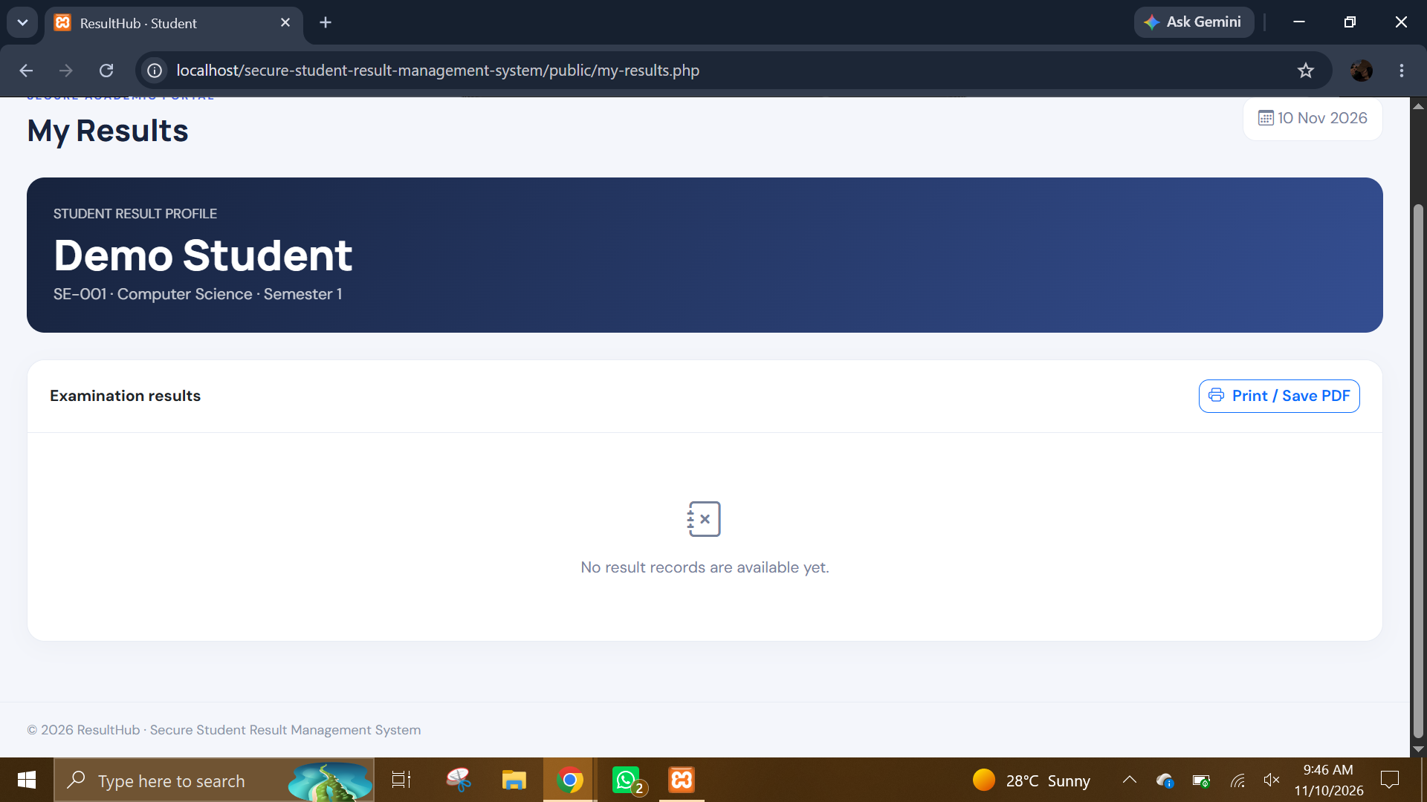
Student results page - no records. Shows the student profile and the examination results panel with a message that no result records are available yet. The Print/Save PDF action is also visible; this is an empty-state example.
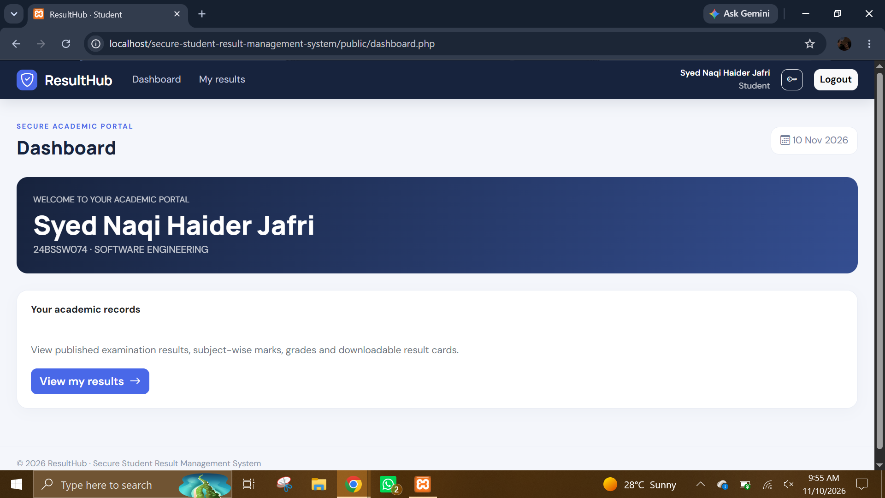
Student dashboard - named student profile. Shows the dashboard for the named student account, including the student identity and an action to open personal results. It demonstrates the role-specific dashboard using a populated profile.
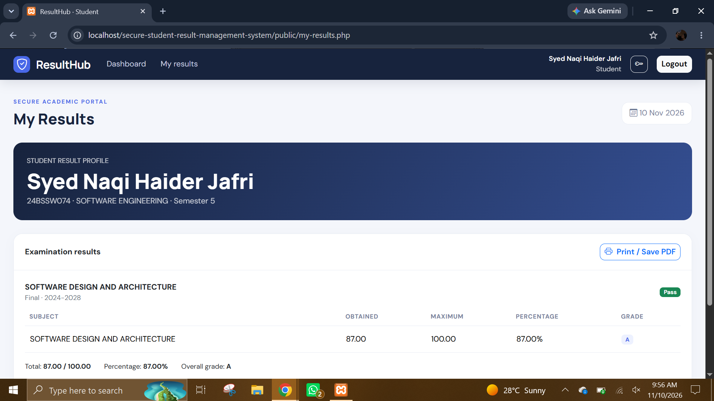
Student result card - populated. Shows an examination result with subject-level obtained and maximum marks, percentage and letter grade, along with total marks, overall percentage, overall grade and pass/fail status. It demonstrates the student’s read-only result view
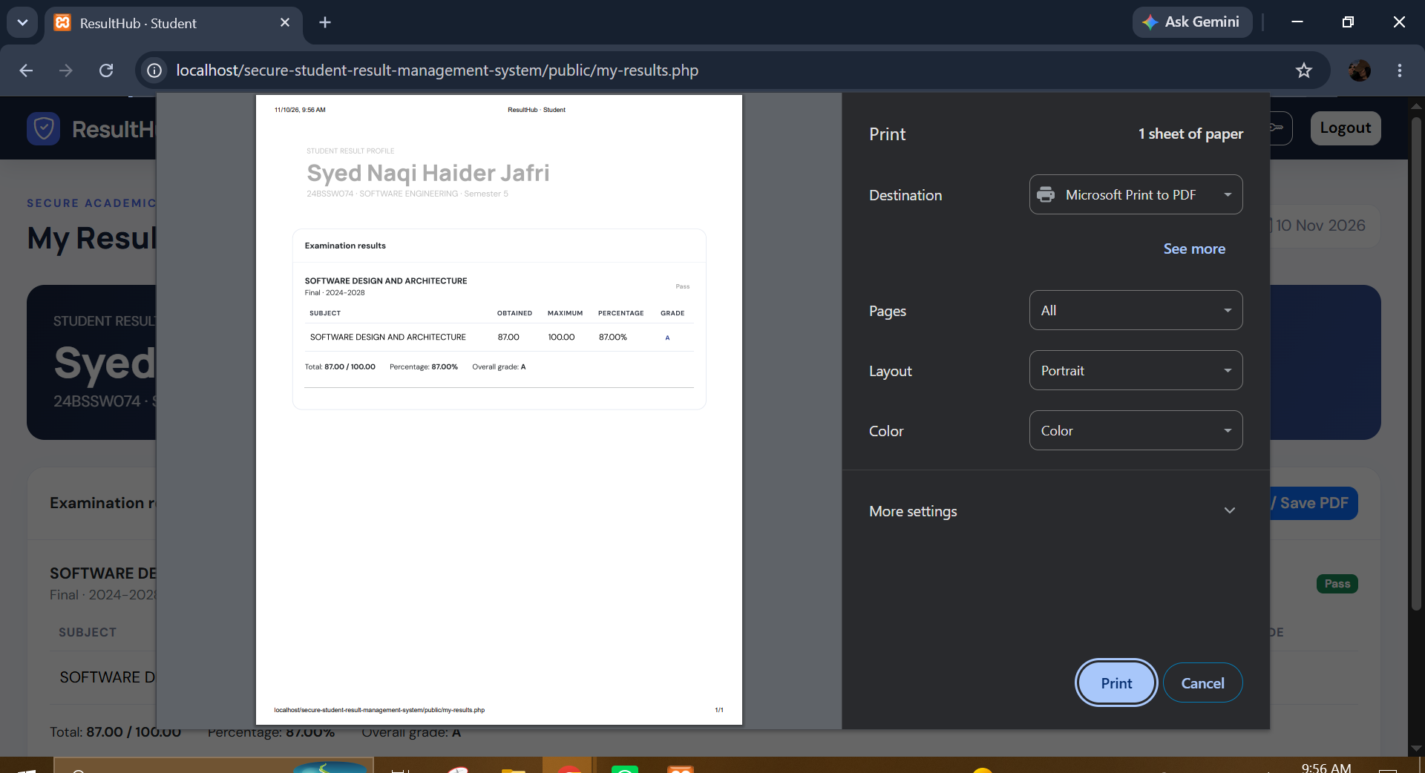
Browser print preview for result card. Shows the browser’s print dialog with the result page preview and PDF/print destination options. It demonstrates the application’s browser-based route for printing or saving the result page as a PDF.
- VALIDATION SCREENSHOTS: The final two screenshots provide direct validation evidence: invalid marks are rejected and invalid or inactive-account credentials do not authenticate.
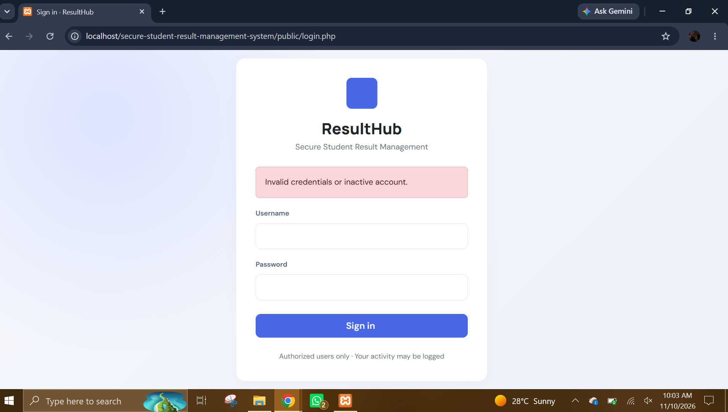
Invalid login credentials message. Shows the login page displaying an error for invalid credentials or an inactive account. The message confirms that the attempted sign-in did not create an authenticated session.
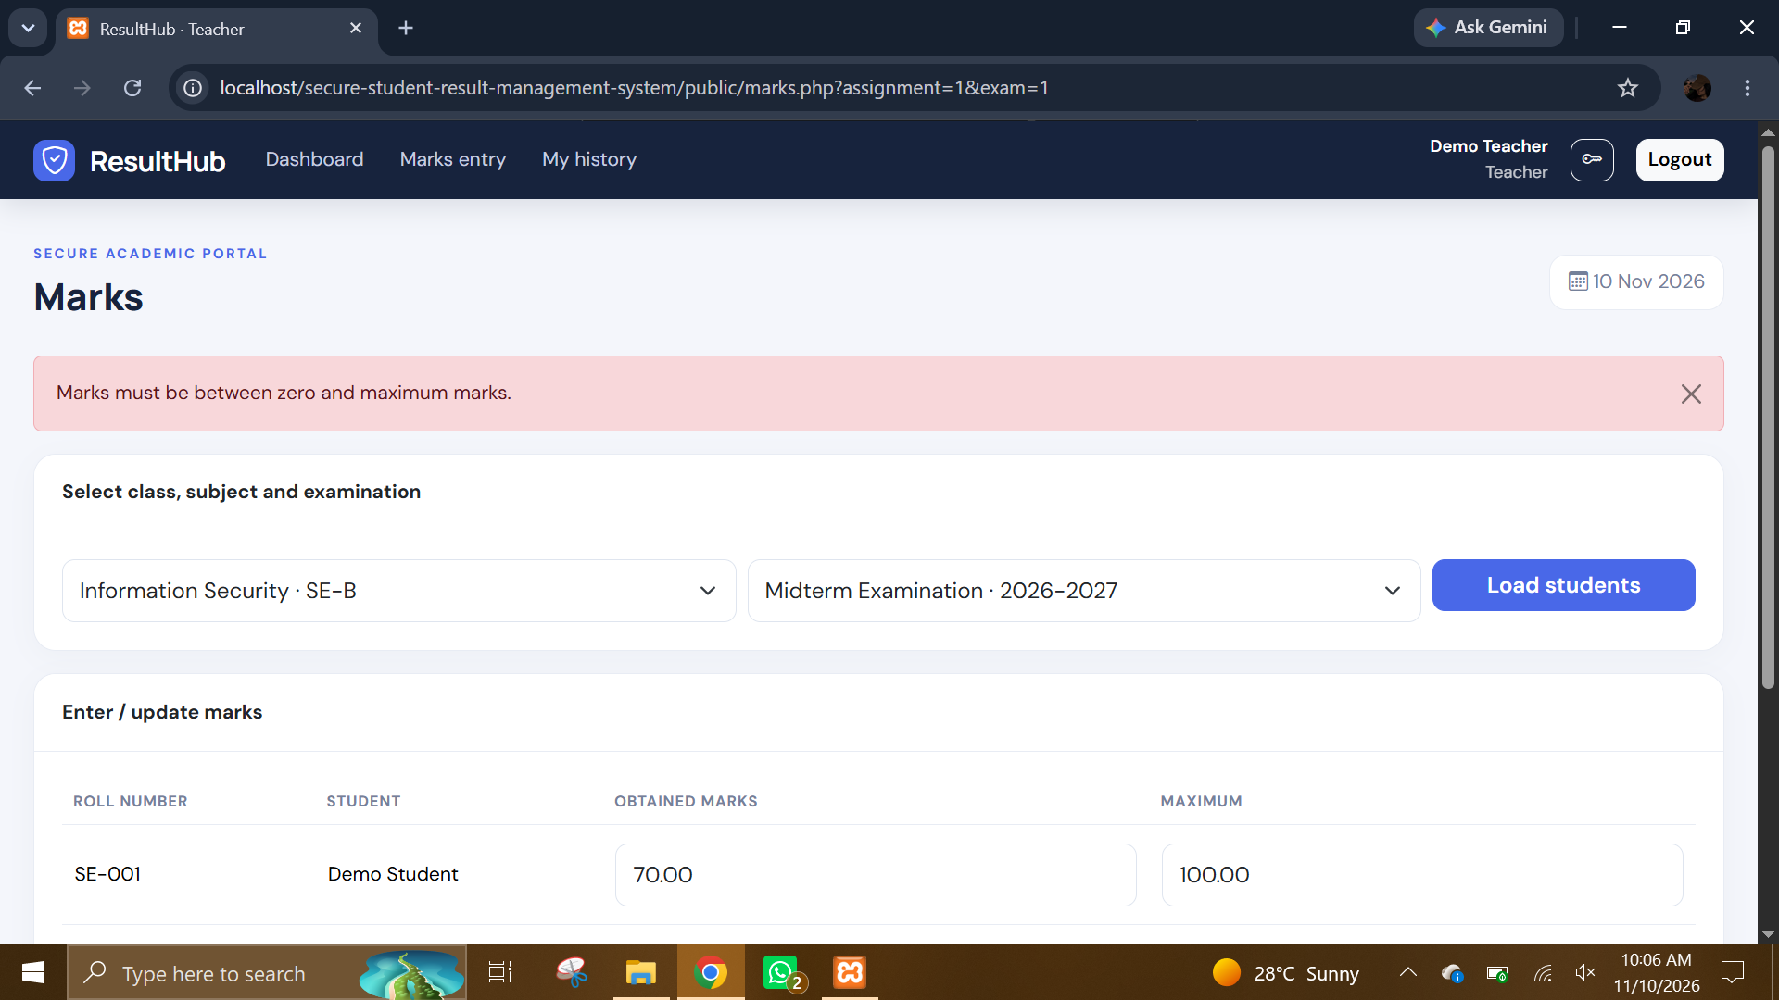
Marks-above-maximum validation error. Shows the teacher marks page displaying a red validation banner stating that marks must be between zero and the maximum. The invalid entered value is rejected instead of being saved.
- GitHub link:
https://github.com/naqi123-4/secure-student-result-management-system

